AND GATE: 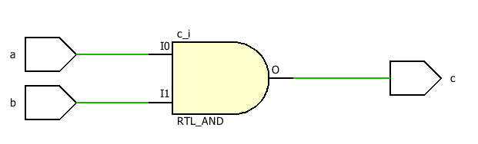

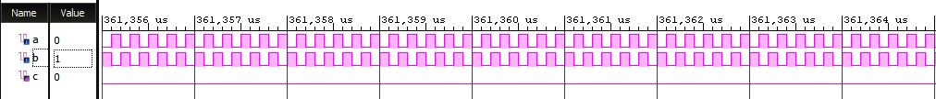

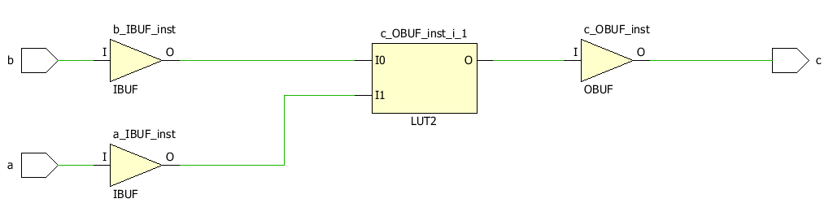

OR GATE:

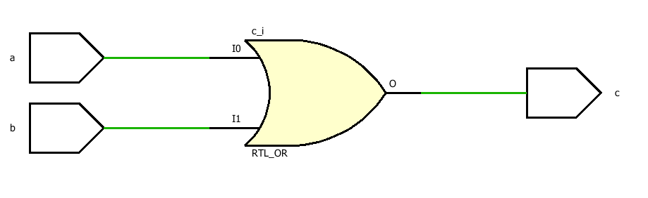

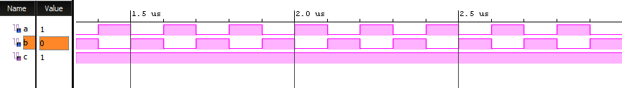

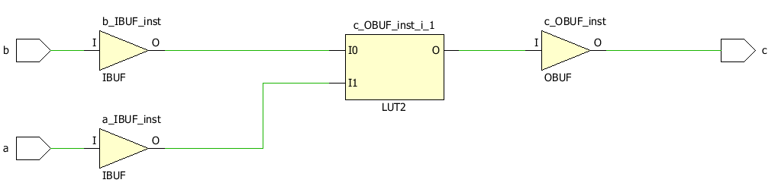

NOT GATE:

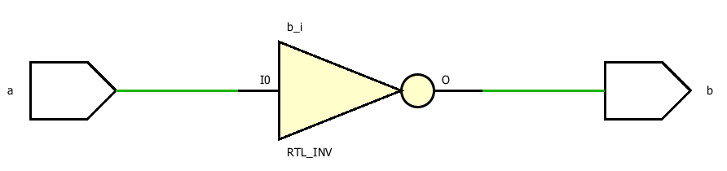

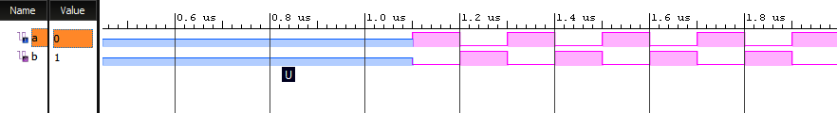

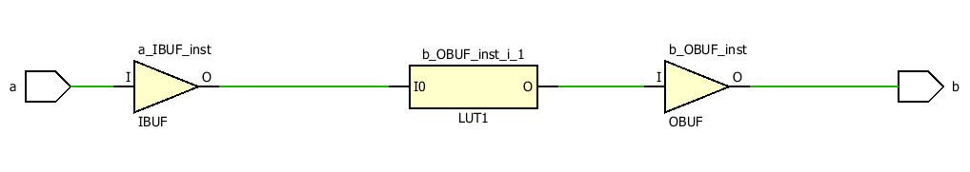

NAND GATE:

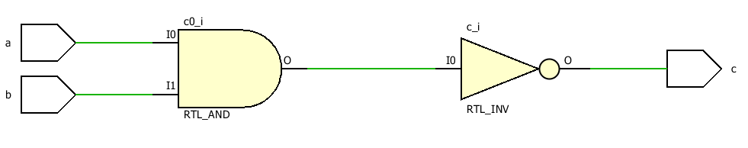

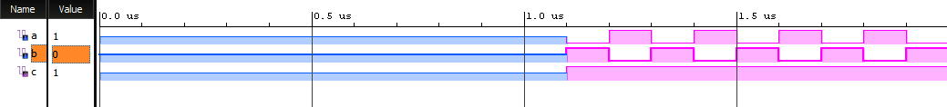

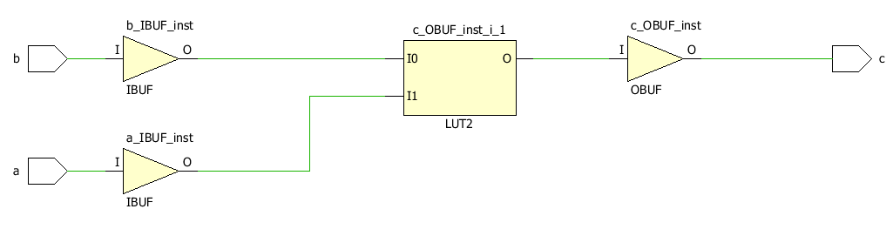

NOR GATE:

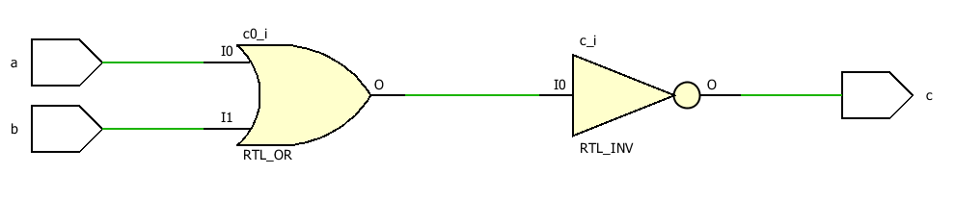

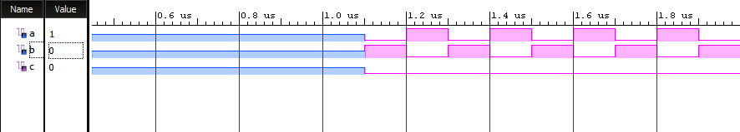

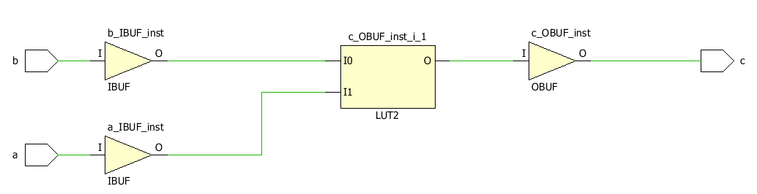

EX-OR GATE:

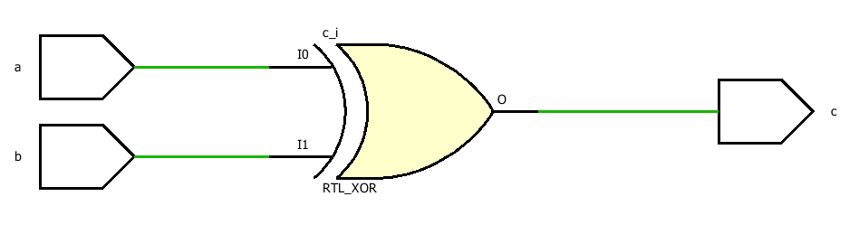

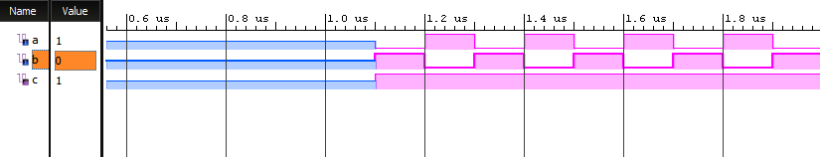

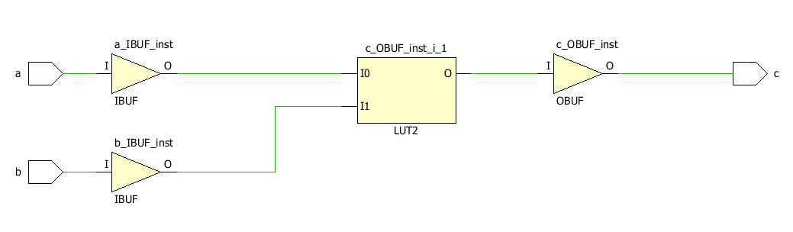

EX-NOR GATE:

